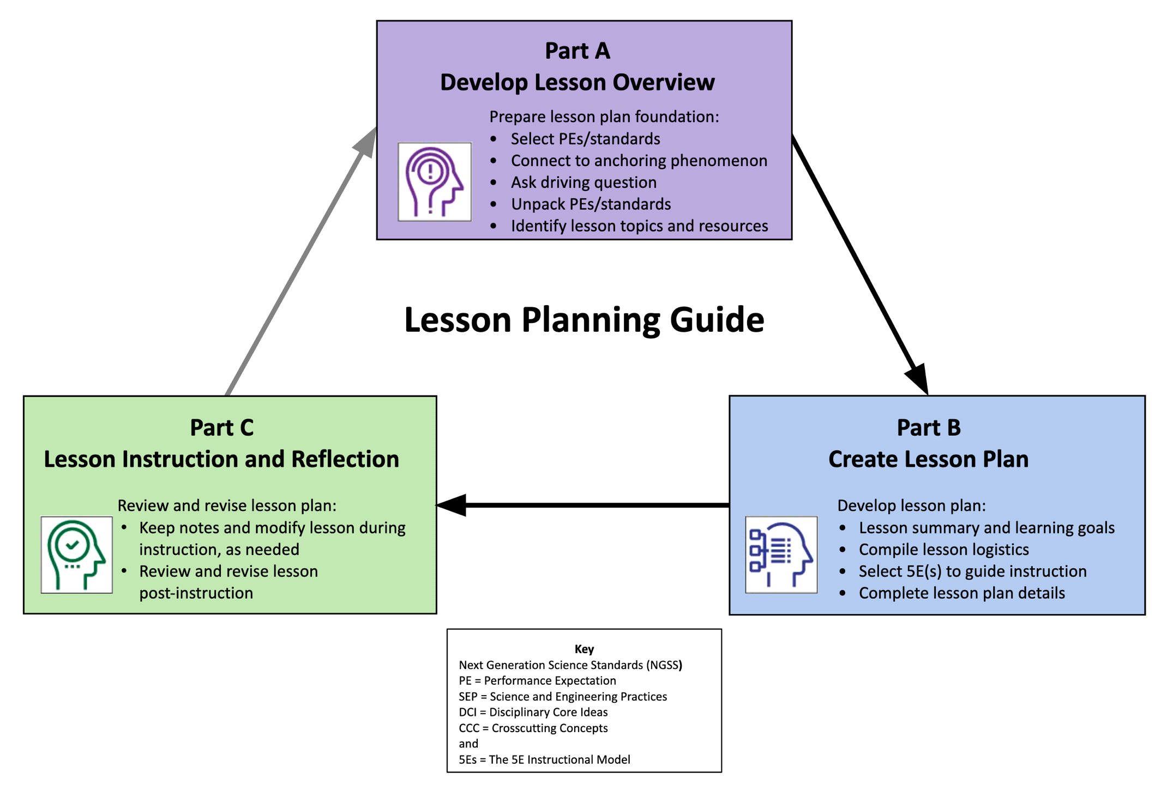

Lesson Planning Guide
Develop Lesson Plans for Instruction
Steps in developing NGSS-/standards-aligned, phenomenon-based lessons that are guided by the 5Es instructional model:
- Complete the Lesson Plan Overview (Part A) to guide development of lesson plans.
- Use the Lesson Plan Template (Part B) to create detailed lesson plans.

 | Lesson Overview Template (Part A)
1.a Select grade level NGSS Performance Expectations (PEs) or Topics, or district/state standards that support lesson-based student learning goals.
For NGSS, PE color coding reflects its 3-dimensional learning components. Search the Evidence Statements for details on what students should know and do.
Grade level is middle school grade learners (6-8). Sand location is Kansas City, MO.
Ms-ESS2-2: Understand and interpret geomorpholoy based on weathering, erosion, and mild tectonic activity, including mineral identification. Discuss and identify similarities in mineral type and formation along with the importance of the cooling process, hardness, volcanism, and fluvial deposits when pertaining to sedimentary features and structures. Less emphasis on the formation of sand, and more on what the sand can tell us about the environment.
1.b Identify a lesson-based anchoring phenomenon that builds towards understanding of the PEs/standards, and is engaging and relevant to students.
See more about phenomena and using phenomena with NGSS.
Phenomenon: 1C: The class builds a record of what everyone else noticed.
1.c Ask a Driving Question, which is authentic and student-focused, that relates to investigating the PEs/standards and phenomenon.
See more about Driving Questions and using Driving Questions with NGSS.
What can the differences of sand composition tell us about the environment? Can you tell how certain parts of the world formed differently just by using sand?
1.d Unpack the 3-D learning components of the Performance Expectations/standards in the table below.
For NGSS guidance, see the NGSS Topic Arrangements and NGSS DCI Arrangements. Use tools to unpack each PE separately.
Science and Engineering Practices (SEP)  (skills) |  | Disciplinary Core Ideas (DCI)  (content) | Crosscutting Concepts (CCC)  (connections)
Constructing Explanations and Designing Solutions:  Construct an explanation based around known factors of science. Hypothesis can be determined using the Science of Sand website to compare local sand samples and choice sand samples that will be collected from around the world. An explanation will be required for the change in sand type and its association with the environment. |  | ESS1.C :Rock strata and the fossil record can be  used as evidence to organize the  relative occurrence of major historical  events in Earth’s history. A closer look at sand can determine the fall and rise of local rock strata and the part tectonics play in land deformation, using sand samples. | Systems and system models. Defining the system under study—specifying its boundaries and  making explicit a model of that system—provides tools for understanding and testing ideas that  are applicable throughout science and engineering.  Working through the basic understandings of fluvial systems and hardness will help understand sand shape and mineralization, thus leading to a better udnerstanding of the formations of the past, above and below.
1.e Determine students’ prior knowledge about the lesson concepts. (e.g., pre-test, class discussion, exit ticket, 1-minute report, KWL chart, survey, etc.)
A class discussion will take place where students will be prompted by questions and the entire class will form a hypothesis about the questions at hand. The actual answers to those questions will then shape a new hypothesis.
1.f Identify Lesson Topics and Learning Goals: List main lesson concepts related to grade level PEs/standards that support student learning goals in figuring out the anchoring phenomenon; revise as needed.
1) hardness and how it affects sand roundness and angularity
2) how roundness can lead to an assumption of hardness and therefore length traveled in fluvium and/or local rock formations present
3) how rocks tumble and gradually break down to induce roundness
4) Generating a hypothesis using the scientific method about 2 locations and their geologic past. A local sand sample will be used and a sand sample that is almost completely different from the local.

1.g Select Lesson Resources: Identify resources to develop lessons that address the PEs/standards and investigate the anchoring phenomenon through a variety of sequenced activities; revise as needed (include title and URL).
Local sand will be collected and looked at along with sand fromt the opposite region. www.scienceofsand.info will be used to compare and contrast sand samples. The first sample will be collected from the Missouri River and the second from Punalu'u Beach, Hawaii.

 | Lesson Plan Template (Part B)
Grade and Subject | Middle School: physical science |  |  |  | Instructional Time  (min.) | 180 (3 days)
Lesson Title (Topic) | Sands Place on Earth
Anchoring Phenomenon  (copy from 1.b) | 1C: The class builds a record of what everyone else noticed.
Driving Question  (copy from 1.c) | What can the differences of sand composition tell us about the environment? Can you tell how certain parts of the world formed differently just by using sand?
Lesson Overview
Lesson Summary  (description) |  |  | Lesson Topics and Student Learning Goals  (copy from 1.f)
The lesson will start with an open discussion about sand and why it is important. A hypothesis will be generated by the entire class to determine the environment the sand samples came from. A lecture will be given about how water can round sand and a chart that associates different color with different minerals and different environments will be given. The students will then use this tool to make a new assumption and formulate a new hypothesis. |  |  | 1. Fluvial water system and understanding of roundness and hardness  2. volcanic topics and simple tectonics and the formation of magma  3. simple sedimentary topic and how animals and plants form carbon based sediment.  4. Hypothesis generation using the scientific method
Lesson Resources Aligned with Standards
Lesson Resource  (copy from 1.g, sequenced with titles and links) |  |  | Resource Standards Alignment  (copy from 1.d, standards notated, link optional)
Local sand will be collected and looked at along with sand fromt the opposite region. www.scienceofsand.info will be used to compare and contrast sand samples. The first sample will be collected from the Missouri River and the second from Punalu'u Beach, Hawaii. |  |  | Constructing Explanations and Designing Solutions:  Construct an explanation based around known factors of science. Hypothesis can be determined using the Science of Sand website to compare local sand samples and choice sand samples that will be collected from around the world. An explanation will be required for the change in sand type and its association with the environment.  ESS1.C :Rock strata and the fossil record can be  used as evidence to organize the  relative occurrence of major historical  events in Earth’s history. A closer look at sand can determine the fall and rise of local rock strata and the part tectonics play in land deformation, using sand samples.  Systems and system models. Defining the system under study—specifying its boundaries and  making explicit a model of that system—provides tools for understanding and testing ideas that  are applicable throughout science and engineering.  Working through the basic understandings of fluvial systems and hardness will help understand sand shape and mineralization, thus leading to a better udnerstanding of the formations of the past, above and below.
Sand for identification |  |  | Sand samples obtained
Teacher Preparation
Student Misconceptions  (potential student ideas that are problematic when engaging in the lesson) |  |  | Scientific Terminology  (vocabulary named once students “figure out” concepts of lesson)
Students might have issues understanding that forces much lower and slower than they can imagine can make such large structures. They might find it difficult to understand that they are living on a sea of dead plants and animals and volcanic activity |  |  | Fluvian, volcanic, basalt, quartz, minerals, roundness, hardness, sedimentary, magma
Materials Preparation
Student Needs  (activity sheets, data packet, etc.) |  | Group Needs  (lab equipment, group data packets, etc.) |  | Safety & Technology Needs  (unsafe materials, websites cued, etc.)
Pen, paper, sand, science of sand website |  | Sand, communication |  | none
Supporting Information
References  (links to cite sources of data, images, websites, etc.) |  |  | Background Reading  (for teachers and/or students)
www.scienceofsand.info |  |  | tectonics

Complete the 5E Instructional Model section(s) that are relevant to the lesson:

Engage: Interest in a concept is generated and students’ current understanding is assessed.
ACTIVATE interest: Introduce anchoring phenomenon and driving question.
- Engages students in the concepts through a short activity or relevant discussion
- Connects students’ past and present experiences
- Creates interest and generates curiosity
- Uncovers students’ current knowledge and misconceptions
- Initiates students’ investigation into the anchoring phenomenon based on an observation, problem, or question
Phenomenon-based Driving Questions (questions students are likely to ask about the lesson topic)
How do rocks move? How old is the earth? How long does it take for sand on a mountain to reach the ocean?
Lesson Activities (experiment, demonstration, video, visualization, reading, etc., coherently sequenced to help build understanding of PE/standard)
For each activity, provide details of the procedure including timing, teacher guidance, student prompts, strategies for discussions and differentiation, etc.
A before class discussion will take place where the students will look at the sand as a group without having any prior knowledge. They will formulate a hypothesis about the environment this sand came from.
Sand from the local area and sand from a volcanic are (black sand) will be shown.
After the hypothesis, a short explanation of fluvial environments, volcanism, roundness and hardness, and sedimentary structures will be given.
Pictures of structures from google images might be shown.
A handout that will have color coded minerals and a roundness scale and its description of the environments each come from will be handed out.
The students as a group will then be asked to make a new hypothesis.
A compare and contrast of the hypotheses will take place.
Formative Assessment (activity sheet, Venn diagram, summary, exit ticket, think-pair-share, etc. to check for understanding of lesson concepts)
A sheet with color coded minerals and rocks, their hardness, and a roundness scale will be given. It will be used to generate a new hypothesis as a whole class.
Consensus Discussion (claims, evidence, and reasoning on what students figured out in this lesson)
Discussion will be the hypothesis comparison. Understanding and comparing local environments with an area unlike where the student lives will help with the understanding that the world is vastly different for different reasons.
Discussion on fluvial systems, volcanics, and mineralogy will take place.
New Questions and Next Steps (student-driven questions, ideas on what to investigate in the next lesson and how to investigate it, etc.)
What might have caused the sands to originate in their original locations?
Why would a volcano be important to sand generation?
Why would hardness be important other than distance?
Next lesson: A set of random sand samples will be set up and students will be able to work in groups of 2 and take their samples home. They will have 2 weeks to prepare a report about the origin of their sample which will be given in front of the class. They can use any sources, including the instructor. The instructor will set aside 3 days to answer questions the last 20 min of class to students.

SANDS OF TIME
Class assessment
1) Using what you learned, how do you feel about knowing the age of the Earth?
2) If volcanoes become extinct, how are they still producing sand?
3) As you learned, a black sand is very different from a white sand. Write a paragraph
explaining why that is
4) Describe why roundness is important?
5) Do you feel like you have an overall better understanding of how the earth works? Why
or why not.

